Royal University of Dhaka
House No# 2, Road No#10, Block # E, Banani, Dhaka -1213
Phone: +880-2-9886150, +880-2-9841628
E-mail: info@royal.edu.bd Website: www.royal.edu.bd

Application Form
For ID Card
Please fill up the form in Capital Letters only

Valid:

Name of the Student :

ID No. :

Department / Program :

Batch No. :

Personal Mobile No. :

Blood Group :

Signature of the Students

PHOTO
Royal University of Dhaka
House No# 2, Road No#10, Block # E, Banani, Dhaka -1213
Phone: +880-2-9886150, +880-2-9841628
E-mail: info@royal.edu.bd Website: www.royal.edu.bd

Application Form
For ID Card
Please fill up the form in Capital Letters only

Valid:

Name of the Student :

ID No. :

Department / Program :

Batch No. :

Personal Mobile No. :

Blood Group :

Signature of the Students

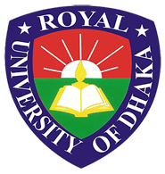

PHOTO

